**NUGGETS**

**FOR**

**CHRIST CHURCH, ST ANDREW’S AND ST MICHAEL’S**

**1ST JULY 2025**

Hello everyone!

As I write, I am feeling rather hot and looking forward to some cooler English weather. Which made me think that July includes St Swithin’s Day and we know that if it rains then, it rains for the next 40 days! Thinking about the weather I found the image below which shows a relationship between climate, weather and temperatures. I am not showing it to look at that correlation – I am showing it to help us to think about our world; the impact that people have had on our world, whilst reflecting on God’s creation and all that he has given us – to care for, to love, to look at with awe, to challenge us about how we ourselves care for the world God has made, and how we care for the peoples within it. As Jesus came to declare his love for each one of us, so he calls us to love our world. Perhaps that can be July’s challenge as we see what the 15th July holds for us!

 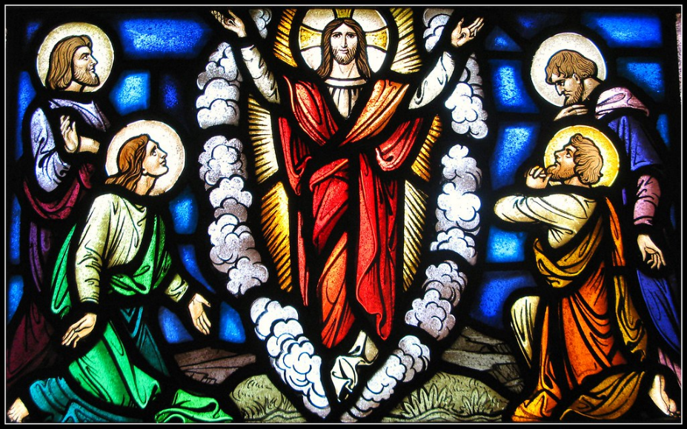

**JULY**

**Coffee Morning at St Michael’s**

The summer season of Coffee Mornings is in full swing at St Michael’s, and the next one takes place on **Thursday 3rd July from 10.30am to 12.00 noon.** Do come along for cakes, refreshments, a chat, a chance to win prizes or acquire books with all monies raised going to the Women’s Refuge.

**Sunday 6th July 2025**

**St Michael’s**

9.00am – Holy Communion

**Christ Church**

10.00am – Morning Worship

**St Andrew’s**

10.30am – Family Service

**Coffee Morning at St Andrew’s**

Our next Coffee Morning at St Andrew’s takes place on **Wednesday 9th July from 10.30am to 12.30pm**. Do come along for lovely cakes, refreshments and for a chat.

**PCC at St Michael’s**

The next PCC Meeting for St Michael’s is on **Thursday 10th July at 10.30am** in the church. Please let a PCC member know if there is anything you would like discussed.

**Coffee Connect at Christ Church**

Coffee Connect meets on **Friday 11th July from 2.00 to 4.00pm** at Christ Church. Come along to meet others for a chat and enjoy homemade cakes and biscuits.

**Prayer Breakfast at Christ Church**

The next Prayer Breakfast meets on **Saturday 12th July from 8.15am** for church cleaning, **prayer from 9.00am** followed by breakfast. All welcome.

**Sunday 13th July 2025**

**Christ Church**

10.00am – Morning Worship

3.00pm – Afternoon Holy Communion

**St Andrew’s**

10.30am – Holy Communion and Baptism

**St Michael’s**

5.00pm – Evening Prayer

**Sunday 20th July 2025**

**St Michael’s**

9.00am – Morning Prayer

**Christ Church**

10.00am – Holy Communion

**St Andrew’s**

10.30am – Morning Worship

**PCC at St Andrew’s**

The next PCC Meeting for St Andrew’s is on **Wednesday 23rd July at 7.30pm** in the church. Please let a PCC member know if there is anything you would like discussed.

**Coffee Connect at Christ Church**

Coffee Connect meets on **Friday 25th July from 2.00 to 4.00pm** at Christ Church. Come along to meet others for a chat and enjoy homemade cakes and biscuits.

**Sunday 27th July 2025**

**Christ Church**

10.00am – Morning Prayer

**St Andrew’s**

10.30am – Morning Worship and Baptism

**Sunday 27th July 2025 continued**

**St Michael’s**

5.00pm – Holy Communion

**AUGUST**

**Messy Church at Christ Church**

There is a Summer Messy Church at **Christ Church on Friday 1st August from 10.30am to 12.30pm.** There will be activities and a barbecue lunch included. All are welcome to come along; especially children and families.

**Sunday 3rd August 2025**

**St Michael’s**

9.00am – Holy Communion

**Christ Church**

10.00am – Morning Worship followed by Three Churches Barbecue at Christ Church House from midday.

**St Andrew’s**

10.30am – Family Service

**Compline at Christ Church**

There is a short service of Compline **every Friday at 7.30pm** at Christ Church. All are welcome.

**Wanting to be Baptised or Confirmed?**

Please come and see me or catch me at a service. The course continues. Even if you have not made the first one or two but would still be interested in joining please do be in touch. The dates are below and the start time will be **7.30pm.**

**Thursday 10th July** at Christ Church House, PE2 5JJ

**Thursday 24th July** at Christ Church, PE2 5JJ

**With a final date to be arranged with the group.**

Whatever the weather, may we know God’s presence, his love, hope, joy and peace today and always. Yours in Christ. ***Sarah***

[sarahcgower@btinternet.com](mailto:sarahcgower@btinternet.com) 01733 394411